Batch: E-2 Roll No.: 16010123325

Experiment No. 04

TITLE: Develop and demonstrate JavaScript with POP-UP boxes and functions

AIM: To demonstrate the functionalities of JavaScript using HTML and CSS
______________________________________________________________________
Expected Outcome of Experiment: Design static web pages using various HTML tags.
_______________________________________________________________
Books/ Journals/ Websites referred:

- https://www.w3schools.com/js/

_____________________________________________________________________

Describe and utilize Javascript programming concepts such as variables, arrays, conditionals, and loops.
Write and deploy Javascript code to solve practical web design problems.

Problem Statement: Description of the application implemented with output:

a) Input: Click on Display Date button using onclick( ) function
Output: Display date in the textbox
b) Input: A number n obtained using prompt
Output: Factorial of n number using alert
c) Input: A number n obtained using prompt
Output: A multiplication table of numbers from 1 to 10 of n using
d) Write JavaScript to validate the following fields for the registration page.
Name (Name should contain alphabets and the length should not be less than 6 characters).
Password (Password should not be less than 6 characters length).
E-mail id (should not contain any invalid and must follow the standard pattern
name@domain.com)
Phone number (Phone number should contain 10 digits only).

JavaScript Basic Concepts Learned With Syntax

- Event Handling: You used onclick and onsubmit to trigger specific functions when an event occurs.

Syntax: <button onclick="displayDate ()">Display Date</button>

- DOM Manipulation: You dynamically updated or accessed elements using their IDs

Syntax: document.getElementById(‘dateBox’).value = today.toLocaleString();

User Input via Prompt: You used prompt() to gather user input and perform calculations.
Syntax: const n = parseInt(prompt("Enter a number to find its factorial:", ""));

Alerts for Feedback : Alerts were used to inform users of results or errors.
Syntax: alert(`The factorial of ${n} is ${factorial}.`);

- Loops:

Syntax: for (let i = 1; i <= n; i++) {
factorial *= i;
}

- Form Validation:

Syntax : if (!/^[a-zA-Z]{6,}$/.test(name)) {
alert("Name should contain only alphabets");
}
if (!emailPattern.test(email)) {
alert("Invalid email.");
}

- Function Design: Separating code logic into clear, reusable functions
displayDate(), calculateFactorial(), displayMultiplicationTable(), and validateForm().

Description of the application implemented with output:

- Display Date

Input: Click "Display Date" button.

Output: Shows the current date in the textbox using the displayDate() function.

- Factorial Calculation
Input: Enter a number via prompt().
Output: Displays factorial of the number using alert().
- Multiplication Table
Input: Enter a number via prompt().
Output: Shows the multiplication table (1 to 10) via alert().
- Registration Form Validation
Name: Must be alphabetic, at least 6 characters.
Password: Minimum length of 6 characters.
Email: Valid format (e.g., name@domain.com).
Phone: Must be 10 digits long.

Code:
<!DOCTYPE html>
<html lang="en">
<head>
<meta charset="UTF-8">
<meta name="viewport" content="width=device-width, initial-scale=1.0">
<title>Combined Exercises</title>
</head>
<body>
<header>
<h1>Shreyans Tatiya</h1>
<p>Roll Number: 16010123325</p>
</header>

<section id="registrationSection">
<h2>Registration Form</h2>
<form id="registrationForm">
<label for="nameInput">Name:</label>
<input type="text" id="nameInput" required>

<label for="passwordInput">Password:</label>
<input type="password" id="passwordInput" minlength="6" required>

<label for="emailInput">Email:</label>
<input type="email" id="emailInput" required>

<label for="phoneInput">Phone:</label>
<input type="tel" id="phoneInput" pattern="[0-9]{10}" required>

<button type="submit">Register</button>
</form>
</section>

<section id="multiplicationSection">
<h2>Multiplication Table</h2>
<div>
<label for="numberInput">Enter a number:</label>
<input type="number" id="numberInput">
<button onclick="generateTable()">Generate Table</button>
<div id="multiplicationTable"></div>
</div>
</section>

<section id="dateSection">
<h2>Display Date</h2>
<div>
<input type="text" id="dateInput">
<button onclick="displayDate()">Display Date</button>
</div>
</section>

<section id="factorialSection">
<h2>Factorial Calculator</h2>
<div>
<button onclick="calculateFactorial()">Calculate Factorial</button>
<p id="factorialResult"></p>
</div>
</section>

<script>
// Registration Form Validation
const nameInput = document.getElementById("nameInput");
const passwordInput = document.getElementById("passwordInput");
const emailInput = document.getElementById("emailInput");
const phoneInput = document.getElementById("phoneInput");
const registrationForm = document.getElementById("registrationForm");

function validateName() {
const name = nameInput.value.trim();
if (/^[a-zA-Z]{6,}$/.test(name)) {
nameInput.setCustomValidity("");
} else {
nameInput.setCustomValidity(
"Name should contain alphabets and the length should not be less than 6 characters.");
}
}

function validatePassword() {
const password = passwordInput.value;
if (password.length >= 6) {
passwordInput.setCustomValidity("");
} else {
passwordInput.setCustomValidity("Password should not be less than 6 characters length.");
}
}

function validateEmail() {
const email = emailInput.value.trim();
if (/^[^\s@]+@[^\s@]+\.[^\s@]+$/.test(email)) {
emailInput.setCustomValidity("");
} else {
emailInput.setCustomValidity("Invalid email format.");
}
}

function validatePhone() {
const phone = phoneInput.value.trim();
if (/^[0-9]{10}$/.test(phone)) {
phoneInput.setCustomValidity("");
} else {
phoneInput.setCustomValidity("Phone number should contain 10 digits only.");
}
}

nameInput.addEventListener("input", validateName);
passwordInput.addEventListener("input", validatePassword);
emailInput.addEventListener("input", validateEmail);
phoneInput.addEventListener("input", validatePhone);

registrationForm.addEventListener("submit", function(event) {
event.preventDefault();
if (registrationForm.checkValidity()) {
alert("Registration successful!");
registrationForm.reset();
}
});

// Multiplication Table Generation
function generateTable() {
const numberInput = document.getElementById("numberInput");
const tableContainer = document.getElementById("multiplicationTable");
const n = parseInt(numberInput.value);

if (!isNaN(n)) {
let table = "<table><tr><th>Number</th><th>Multiplication</th></tr>";
for (let i = 1; i <= 10; i++) {
table += `<tr><td>${n}</td><td>${n} x ${i} = ${n * i}</td></tr>`;
}
table += "</table>";
tableContainer.innerHTML = table;

// Log multiplication table to console
for (let i = 1; i <= 10; i++) {
console.log(`${n} x ${i} = ${n * i}`);
}
} else {
tableContainer.innerHTML = "<p>Please enter a valid number.</p>";
}
}

// Display Date
function displayDate() {
const dateInput = document.getElementById("dateInput");
const today = new Date();
const date = today.getDate();
const month = today.getMonth() + 1;
const year = today.getFullYear();
const formattedDate = `${year}-${month}-${date}`;
dateInput.value = formattedDate;
}

// Factorial Calculator
function calculateFactorial() {
const n = parseInt(prompt("Enter a number: "));
if (!isNaN(n)) {
let factorial = 1;
for (let i = 1; i <= n; i++) {
factorial *= i;
}
document.getElementById("factorialResult").textContent = `Factorial of ${n} is ${factorial}`;
alert(`Factorial of ${n} is ${factorial}`);
} else {
alert("Please enter a valid number.");
}
}

// Initial multiplication table (as per the original script)
const a = parseInt(prompt("Enter a number for initial multiplication table: "));
if (!isNaN(a)) {
for (let i = 1; i <= 10; i++) {
const result = a * i;
console.log(`${a} x ${i} = ${result}`);
}
}
</script>
</body>
</html>

Output-
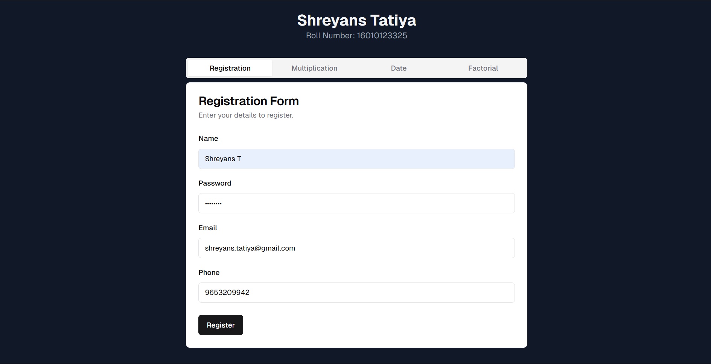
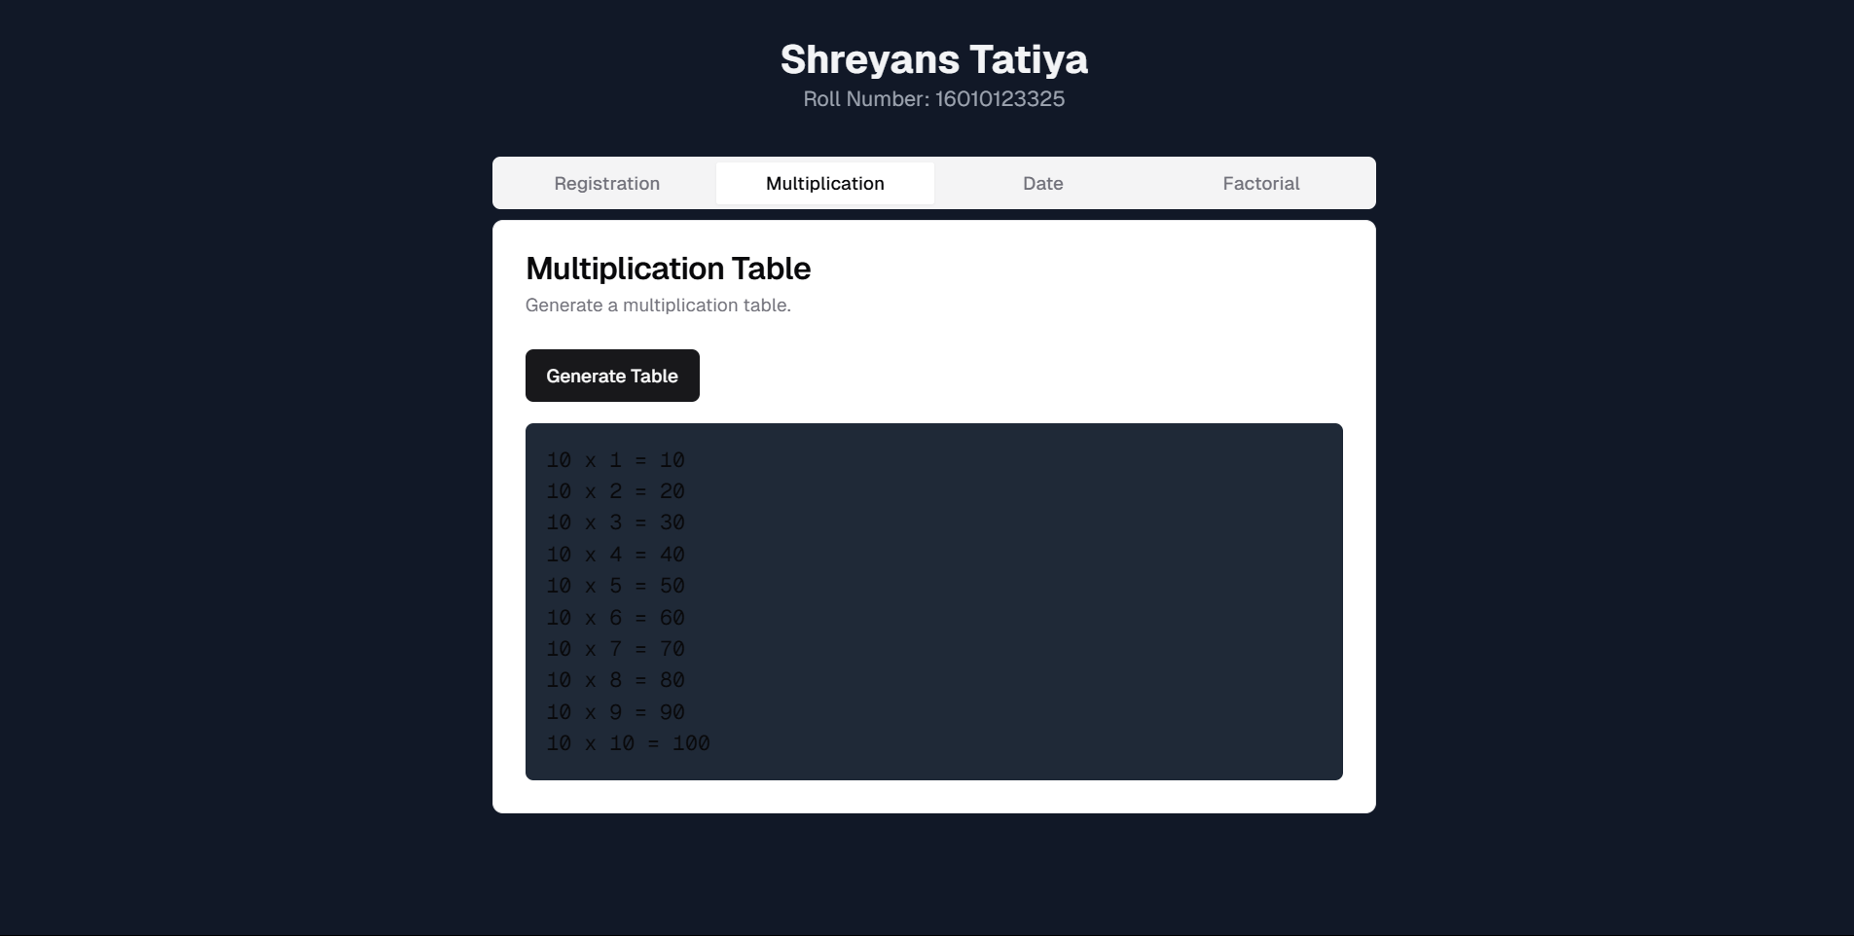

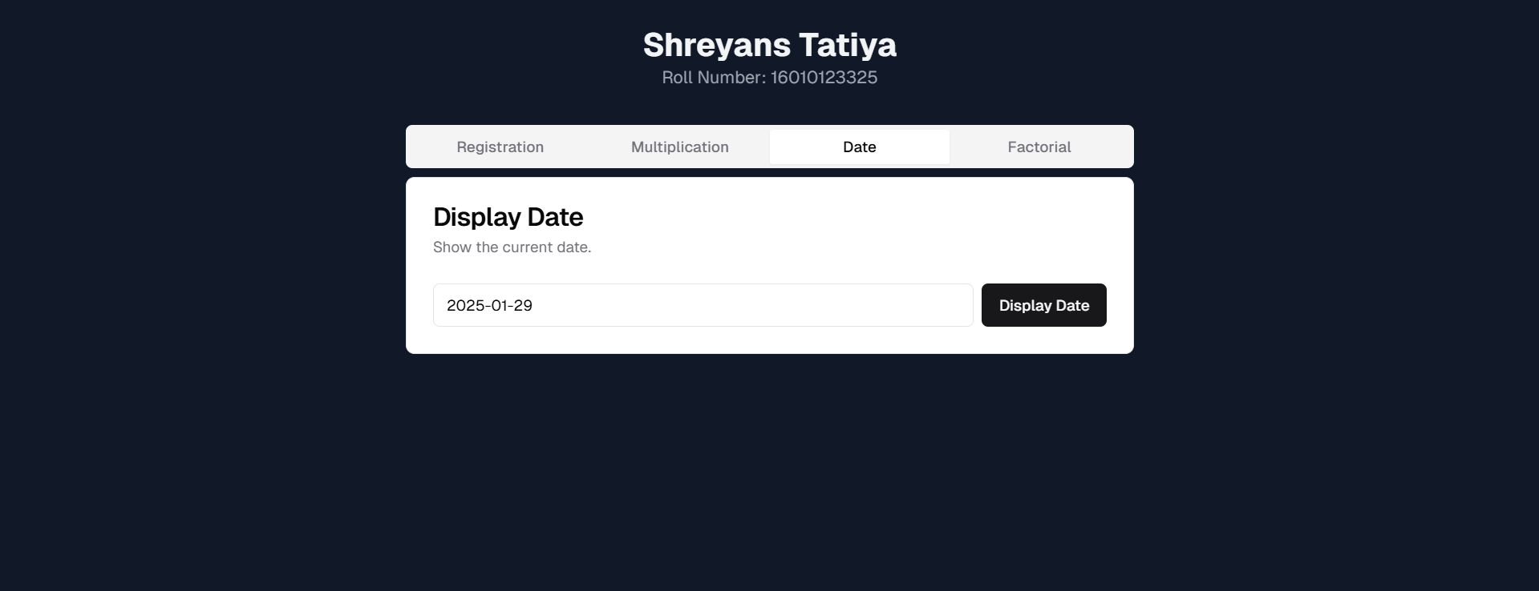
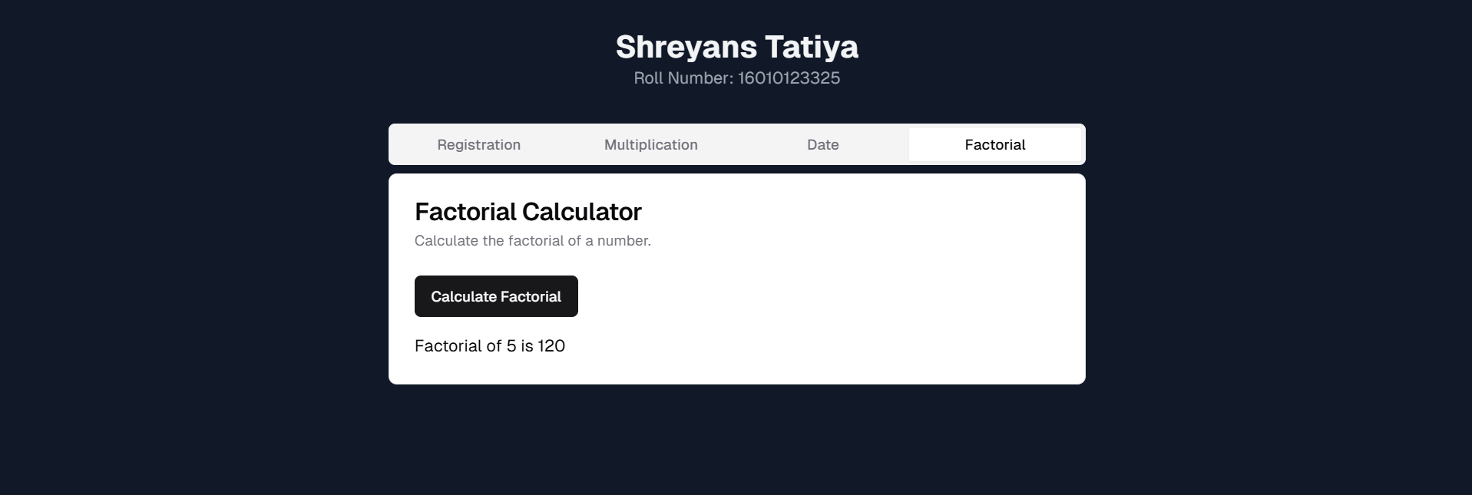

Post Lab Objective with Ans :
What are the possible ways to create objects in JavaScript?
- Object Literals:
const obj = { key: "value" };
- Using the Object Constructor:
const obj = new Object();
obj.key = "value";
- Using a Constructor Function:
function Person(name) {
this.name = name;
}
const person = new Person("John");
- Using the class Keyword:
class Person {
constructor(name) {
this.name = name;
}
}
const person = new Person("Jane");
- Using object. create():
const p= { greet: () => "Hello" };
const obj = Object.create(p);

What is the Difference between == and === operators
- == (Equality Operator):
  - Checks value equality after type coercion.
  - Example:
5 == "5"; // true null == undefined; // true
- === (Strict Equality Operator):
  - Checks both value and type equality.
  - Example:
5 === "5"; // false null === undefined; // false

What is the difference between let and var
var

- The var is a keyword that is used to declare a variable
- Syntax -
var name = value;
- The variables that are defined with var statement have function scope
- We can declare a variable again even if it has been defined previously in the same scope

let

- The let is also a keyword that is used to declare a variable
- Syntax -
let name = value;
- The variables that are defined with let statement have block scope
- We cannot declare a variable more than once if we defined that previously in the same scope

